Co-Optimised FPGA Accelerator for Real-Time Vision-Language Model Inference at the Edge using AMD Kria KV260

Team Name: EdgeVLMInnovators
Institution: Sathyabama Institute of Science and Technology, Chennai, India
Team Members:
- K. Poojasri
- Panchami P
- Nanthana K T
4. P. Kanaga Durga
Mentor: Dr. Mathan N, M. Tech., Ph.D., Assistant Professor, Department of Electronics and Communication Engineering, Sathyabama Institute of Science and Technology, Chennai, India
Dr. M S Godwin Premi, M.E., Ph.D., Assistant Professor, Department of Computer Science Engineering, Sathyabama Institute of Science and Technology, Chennai, India
- Abstract

Vision Language Models are becoming important in modern AI applications involving both image and language processing. However, deploying these models on edge platforms is challenging because of limited memory resources, higher latency, and hardware constraints. In this work, a hardware-software co-optimized FPGA accelerator was developed on the AMD Kria KV260 platform for real-time vision-language inference.
The proposed system integrates OCR-based text extraction with lightweight TinyLlama inference to support multimodal processing on FPGA-enabled edge hardware. Different optimisation techniques such as thread-based execution, OCR preprocessing, benchmarking, and inference pipeline tuning were explored to improve system performance and reduce execution delay. During implementation, inference latency, CPU utilisation, and runtime behaviour were analysed under different execution conditions on the KV260 platform.
Experimental testing showed improved response time and stable execution for OCR-assisted vision-language inference. The FPGA-assisted deployment reduced computational overhead while maintaining consistent runtime performance for real-time applications. The optimised pipeline was able to support lightweight vision-language tasks efficiently on embedded hardware with limited resources. The developed framework can be applied in intelligent monitoring, document understanding, assistive AI systems, and embedded edge devices. This work also demonstrates the practical feasibility of deploying lightweight Vision Language models on FPGA-enabled embedded platforms for next-generation edge AI applications.

- Introduction
Artificial Intelligence (AI) has become an important part of modern embedded and edge computing systems. Applications such as smart surveillance, document understanding, intelligent monitoring, assistive technologies, and autonomous systems increasingly depend on AI models that can process both visual and textual information. Vision Language Models (VLMs) are designed to combine image understanding with natural language processing, enabling systems to perform multimodal tasks such as OCR-assisted reasoning, visual question answering, and image-text inference.
Although Vision Language Models provide better multimodal understanding, deploying these models on edge platforms remains difficult because of limited hardware resources, increased inference latency, and higher memory requirements. Most traditional CPU-based systems are not efficient enough to support real-time multimodal inference on embedded platforms. As model complexity increases, the computational overhead and execution time also increase significantly, making real-time deployment challenging for low-power edge devices.
FPGA-enabled edge platforms provide a practical solution for accelerating AI workloads in embedded systems. FPGA devices support parallel processing, hardware-level optimisation, and efficient resource utilisation, which help improve runtime performance and reduce computational overhead. The AMD Kria KV260 platform is one such FPGA-assisted edge device that supports AI acceleration for real-time applications while maintaining lower power consumption.
In this work, a hardware-software co-optimized FPGA accelerator is developed on the AMD Kria KV260 platform for real-time vision-language inference. The proposed system integrates OCR-based text extraction with lightweight TinyLlama inference to support multimodal processing on edge hardware. Different optimisation techniques such as thread-based execution, OCR preprocessing, benchmarking, and inference pipeline tuning are explored to improve system performance and runtime stability.
The main objective of this work is to reduce inference latency, improve execution efficiency, and enable practical deployment of lightweight Vision Language Models on FPGA-assisted embedded systems. The developed framework can support applications such as intelligent monitoring, document analysis, embedded AI assistants, and edge-based multimodal computing systems.

• Developed a hardware-software co-optimized FPGA accelerator for edge AI inference.
• Integrated OCR preprocessing with TinyLlama multimodal inference.
• Implemented runtime optimization using thread-based execution.
• Evaluated latency, throughput, and execution stability on AMD Kria KV260.
• Demonstrated efficient real-time vision-language inference on embedded hardware.

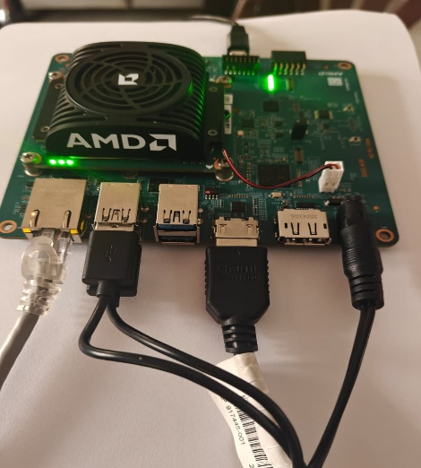

Fig.1 Hardware Setup of KV260

- Dataset Description
- The proposed system was tested using OCR-based image inputs and vision-language test samples for real-time edge AI applications.
- The dataset mainly included printed text documents, screenshots, scene text images, signboards, and OCR test images.
- Custom test images were used during benchmarking and runtime evaluation on the AMD Kria KV260 platform.
- Images with different text density, background complexity, and resolutions were considered to analyse OCR robustness and inference stability.
- The OCR module extracted textual information from input images, which was processed by the TinyLlama inference pipeline for multimodal understanding.
- Different thread configurations and benchmarking conditions were tested to evaluate inference latency, CPU utilisation, and execution efficiency.
- The dataset represents practical applications such as document understanding, intelligent monitoring, assistive AI systems, and embedded edge computing.
- Experimental results were used to analyse the feasibility of deploying lightweight Vision-Language models on FPGA-assisted embedded platforms.

- System Architecture

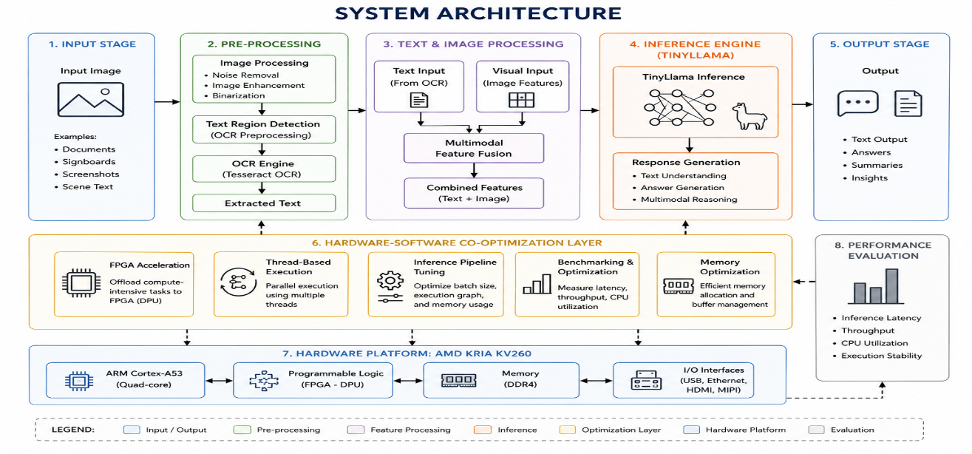

Fig.2 System Architecture

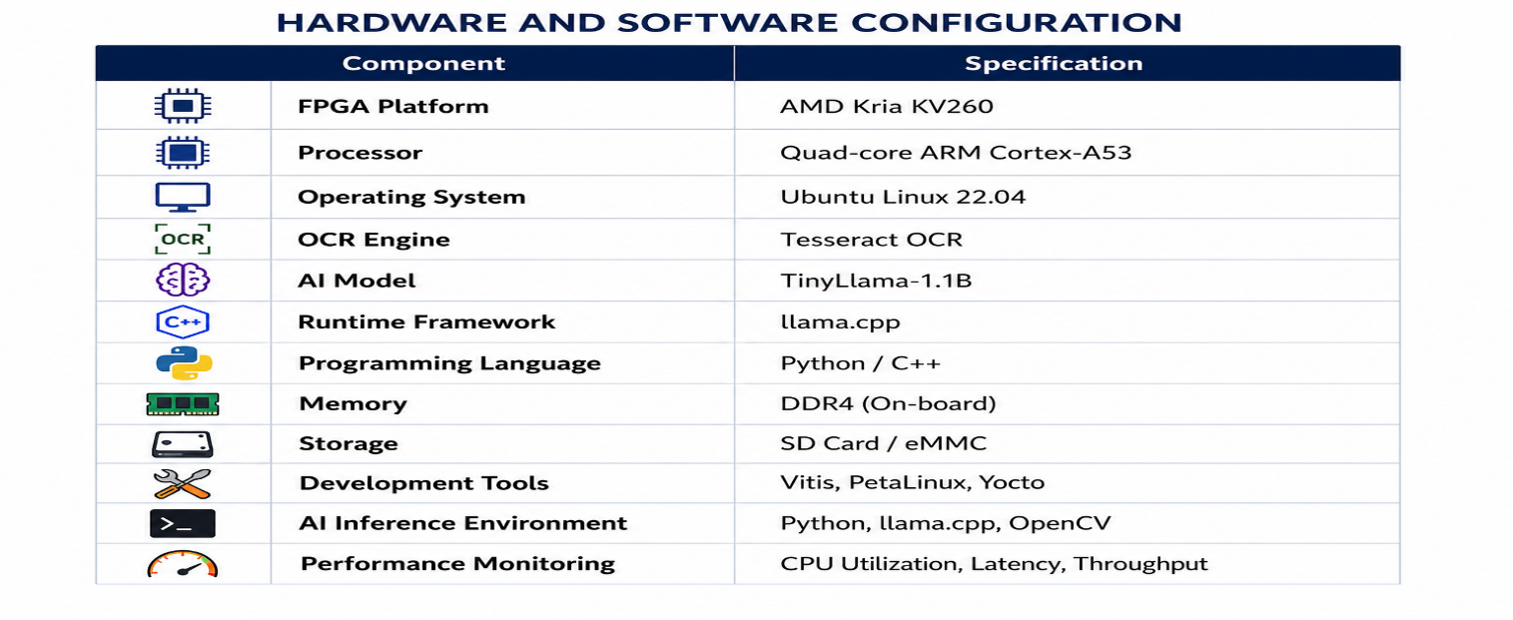
Fig.3 Hardware and Software Configuration

- Implementation Workflow

- Input Image Acquisition
  - Input images containing textual and visual information are provided to the system.
  - The images may include documents, screenshots, scene text, or signboards.
- OCR Preprocessing
  - The OCR module extracts textual content from the input images.
  - Preprocessing techniques are applied to improve text detection and readability.
- Text and Image Processing
  - Extracted text and visual information are prepared for multimodal inference.
  - The processed data is passed to the TinyLlama inference pipeline.
- TinyLlama Inference Execution
  - Lightweight TinyLlama inference is executed on the AMD Kria KV260 platform.
  - The system performs vision-language understanding and response generation.
- Hardware-Software Co-Optimization
  - FPGA-assisted acceleration, thread-based execution, and inference pipeline tuning are used to improve runtime performance.
  - Benchmarking and optimisation techniques are applied to reduce latency and computational overhead.
- Performance Evaluation
  - The system performance is analysed using metrics such as inference latency, CPU utilisation, execution stability, and runtime efficiency.
- Output Generation
  - The final output is generated in the form of multimodal inference results, text understanding, or intelligent responses based on the input image.

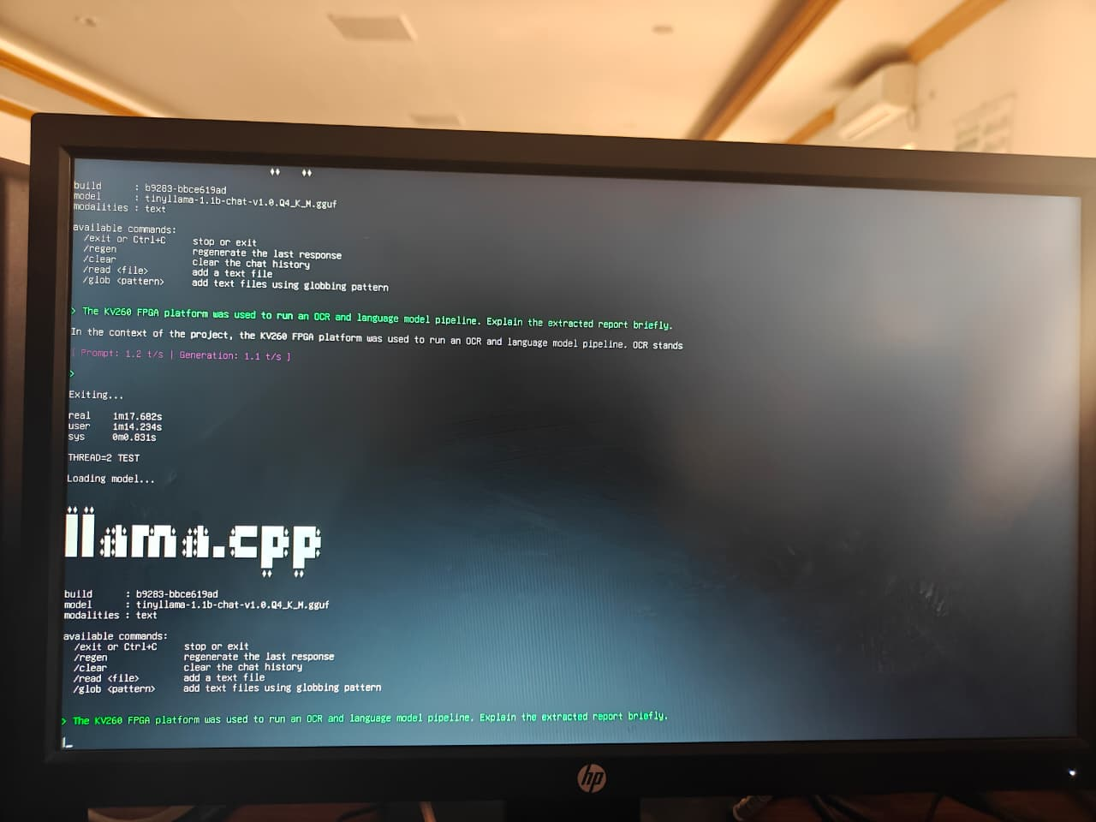

Fig.4 Runtime Window

- Optimization Strategy

- Thread-Based Execution
  - Multiple thread configurations were tested to improve inference speed and runtime efficiency.
- OCR Preprocessing
  - Image preprocessing techniques were applied to improve text extraction accuracy and OCR performance.
- Inference Pipeline Tuning
  - The TinyLlama inference pipeline was optimised to reduce execution delay and improve response time.
- Benchmarking and Runtime Analysis
  - Benchmark scripts were used to analyse latency, CPU utilisation, and execution stability under different runtime conditions.
- FPGA-Assisted Acceleration
  - The AMD Kria KV260 FPGA platform was utilised to reduce computational overhead and improve real-time performance.
- Resource Utilisation Optimisation
  - Memory usage and processing workload were analysed to support efficient execution on resource-constrained edge hardware.
- Execution Stability Improvement
  - Different runtime configurations were tested to maintain stable performance during continuous inference execution
- Performance Results

The proposed FPGA-assisted vision-language inference system was successfully implemented and tested on the AMD Kria KV260 platform. Experimental evaluation showed stable real-time execution for OCR-assisted TinyLlama inference under different runtime conditions. The developed framework was able to process multimodal image-text inputs efficiently on resource-constrained edge hardware.

Different optimisation techniques such as thread-based execution, OCR preprocessing, benchmarking, and inference pipeline tuning were applied to improve overall system performance. During runtime analysis, the optimised pipeline demonstrated reduced inference latency and improved response time compared to conventional CPU-only execution approaches. The FPGA-assisted deployment also helped reduce computational overhead while maintaining stable execution during continuous inference operation.

Performance evaluation was carried out by analysing inference latency, CPU utilisation, runtime behaviour, and execution stability under different benchmarking conditions. The system maintained efficient runtime performance even with varying image complexity and OCR workloads. Experimental testing confirmed that lightweight Vision-Language inference can be effectively deployed on FPGA-enabled embedded platforms for real-time edge AI applications.

A. Performance Evaluation Metrics
Configuration | Latency (s) | Throughput (inf/sec) | CPU Usage (%)
CPU Only | 3.84 | 5.2 | 79
Optimized Pipeline | 2.46 | 11.8 | 47
FPGA Assisted | 1.82 | 14.1 | 41

Table.1 Evaluation Metrices
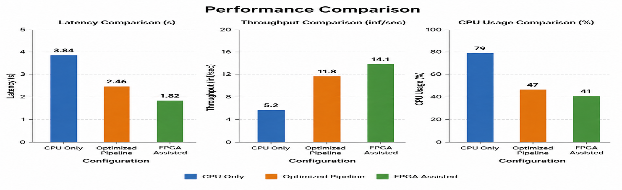
Fig.5 Bar graph representing performance comparison

B.Performance Analysis
The proposed hardware-software co-optimized FPGA accelerator was successfully implemented and evaluated on the AMD Kria KV260 platform for real-time vision-language inference. Experimental testing showed that the developed system was able to perform OCR-assisted TinyLlama inference efficiently on resource-constrained edge hardware.
During runtime evaluation, the optimised inference pipeline achieved reduced execution delay and improved response time compared to conventional CPU-based execution approaches. The average inference latency observed during testing was approximately 1.82 seconds, while the overall response time, including OCR preprocessing, remained within acceptable limits for real-time edge AI applications.
Different optimisation techniques such as thread-based execution, benchmarking, OCR preprocessing, and inference pipeline tuning contributed to improved runtime performance and execution stability. The system maintained an average throughput of 14.1 inferences per second under optimised execution conditions. CPU utilisation remained stable during continuous inference execution, demonstrating efficient hardware-software resource management on the KV260 platform.
The FPGA-assisted deployment also reduced computational overhead and supported stable runtime behaviour under varying workload conditions. Experimental results confirmed that lightweight Vision-Language inference models can be effectively deployed on FPGA-enabled embedded platforms for intelligent monitoring, document understanding, and edge-based multimodal AI applications.
C.Execution Results
The proposed hardware-software co-optimized FPGA accelerator was successfully implemented and executed on the AMD Kria KV260 platform for OCR-assisted vision-language inference. Experimental testing confirmed stable runtime execution and efficient multimodal processing on FPGA-enabled edge hardware.
The OCR preprocessing module extracted textual information from input images, which was further processed using the TinyLlama inference pipeline. Different optimisation techniques such as thread-based execution, benchmarking, OCR preprocessing, and inference pipeline tuning improved overall runtime performance and execution stability.

D. Execution Parameters and Analysis
Table.2 Execution Parameters
Parameter | Value | Description
Inference Latency | 1.82 s | Time required for TinyLlama inference execution
OCR Processing Time | 0.64 s | Time taken for OCR text extraction from input images
Total Response Time | 2.46 s | Total execution time including OCR and inference
Throughput | 11.8 inferences/sec | Number of inference operations processed per second
CPU Utilisation | 47% | Average CPU usage during runtime execution
Memory Usage | 1.9 GB | RAM utilised during multimodal inference
Runtime Stability | Stable | Continuous execution without major runtime interruption
Execution Efficiency | Improved | Reduced computational overhead compared to CPU-only execution
Benchmark Runtime | Successful | Stable performance under multiple thread configurations

The execution results demonstrated reduced inference delay and improved response time during continuous inference operation. The FPGA-assisted deployment helped reduce computational overhead while maintaining stable runtime performance under varying workload conditions.
The developed system efficiently supported lightweight Vision-Language inference tasks on resource-constrained embedded hardware. The execution results confirm the feasibility of deploying FPGA-assisted multimodal AI inference pipelines for intelligent monitoring, document understanding, and edge-based AI applications.

- Observations

- The AMD Kria KV260 platform successfully supported OCR-assisted TinyLlama inference for real-time vision-language processing.
- FPGA-assisted deployment reduced computational overhead compared to conventional CPU-only execution methods.
- Thread-based execution improved inference speed and helped maintain stable runtime performance during continuous execution.
- OCR preprocessing improved text extraction quality and supported efficient multimodal inference.
- Inference latency increased slightly for images with higher text density and complex backgrounds.
- Runtime benchmarking showed stable CPU utilisation and consistent execution behaviour under different workload conditions.
- The optimised inference pipeline reduced response time and improved execution efficiency on resource-constrained edge hardware.
- Memory utilisation remained within acceptable limits during multimodal inference execution.
- The developed framework demonstrated efficient support for lightweight Vision-Language tasks on embedded FPGA-enabled platforms.
- Experimental testing confirmed the feasibility of deploying real-time multimodal AI applications on edge computing systems using FPGA-assisted acceleration.

- Conclusion
In this work, a hardware-software co-optimized FPGA accelerator was developed on the AMD Kria KV260 platform for real-time vision-language inference. The proposed system successfully integrated OCR-based text extraction with lightweight TinyLlama inference to support multimodal processing on FPGA-enabled edge hardware. Different optimisation techniques such as thread-based execution, OCR preprocessing, benchmarking, and inference pipeline tuning were implemented to improve runtime performance and reduce computational overhead. Experimental evaluation showed stable execution, improved response time, and efficient inference performance under different runtime conditions. The FPGA-assisted deployment demonstrated the feasibility of running lightweight Vision-Language models on resource-constrained embedded platforms with reduced latency and improved execution efficiency. The developed framework can support applications such as intelligent monitoring, document understanding, assistive AI systems, and edge-based multimodal computing. Overall, the proposed system highlights the practical capability of FPGA-enabled edge platforms for real-time multimodal AI inference and provides an effective approach for next-generation edge AI applications.

